# CS 255 System Design Document Template

## UML Diagrams

### UML Use Case Diagram

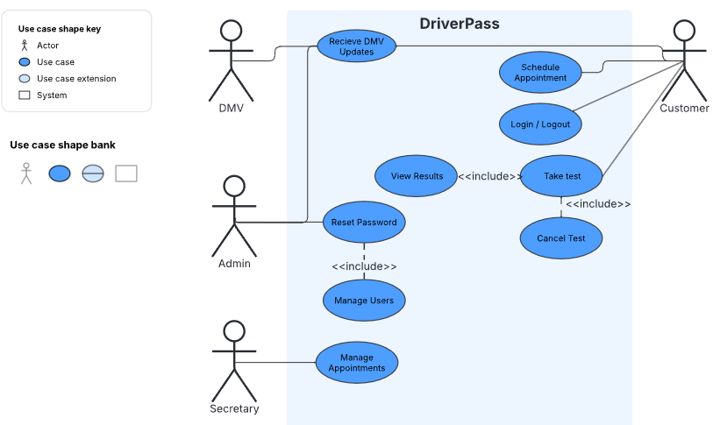

### UML Activity Diagrams

First: shows appointment confirmation use case. || Second: shows user password reset

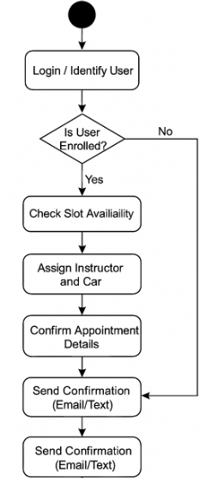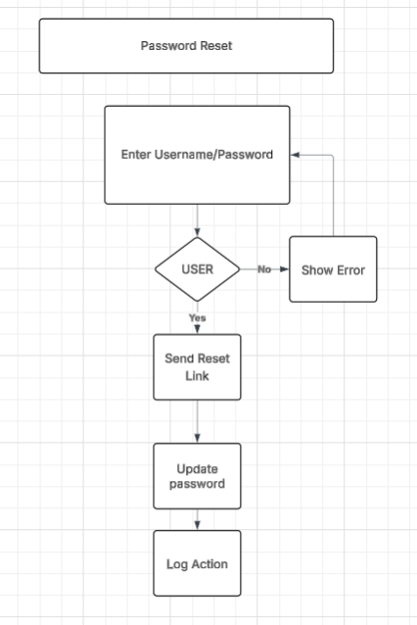

### UML Sequence Diagram

*[You were asked to create a sequence diagram based on* ***one*** *of the use cases you chose. Please insert your sequence diagram here. Check to make sure that you included appropriate components and symbols and that your design meets the client’s needs.]*

### UML Class Diagram

*[You were asked to create a class diagram based on the different classes and attributes needed for your system design. You are* ***not*** *required to include methods, but you may if you wish. Please insert your class diagram here. Check to make sure that you included appropriate components and symbols and that your design meets the client’s requirements.]*

## Technical Requirements

*[Based on the diagrams you have created, describe the technical requirements of your system. These requirements should address the required hardware, software, tools, and infrastructure necessary for your system design.]*